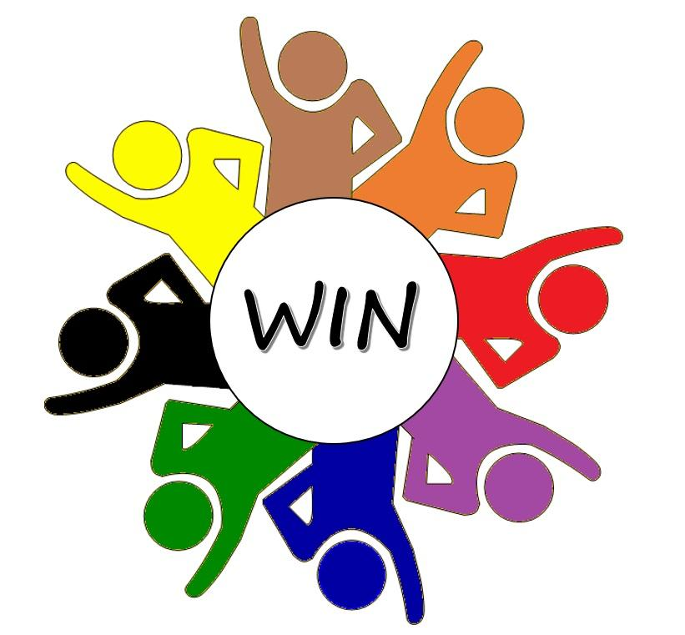

Weight Issues Network - Image Library - Terms and Conditions

WIN has collaborated with a number of organisations to create an image library relevant of Australian use. The images are free to use but must credit the relevant organisation upon use and agree to their terms of use.

- The copyrights to all images in the gallery are owned by respective organisations. No copyright license is granted to the user, other than the right to reproduce the images. Any time you use an image, please credit the relevant organisations in the following way:
© Obesity Action Coalition.
© World Obesity Federation
© Obesity Canada
© WA Health
© WIN
- Prohibited Uses:
  - You may not redistribute or sell the images at any time. Copying or forwarding these images without agreeing to the Terms of Use is a breach of copyright law and is forbidden. If you wish to share our imagery, please share the link to our gallery for others to access that way.
  - Do not alter the original images. You may resize the images to fit into a design.
  - Commercial use of these images is prohibited. Commercial use includes, but is not limited to the following: using the images for retail items or materials intended for sale (such as books, calendars or postcards); adding them to the packaging or in promotion of products intended for sale; including the images in advertising materials or campaigns for a for-profit business.
- All images are approved to download and reproduce for the following purposes:
  - Print, television or digital media reporting;
  - Non-commercial promotional materials (such as brochures for non-profit or community programs);
  - Research and scientific purposes;
  - Educational purposes and materials;
  - Presentations to the public, policy makers, healthcare professionals, etc.
- Any use that promotes weight bias or is harmful to the individuals in the photos is strictly forbidden. You agree to abide by the Media Guide for Obesity when using these photos.

